Ime i prezime..............................................................

- Električne instalacije omogućavaju:
- Priključak na mrež
- Priključak na električnu mrežu
- Priključak na distributivnu mrežu
- ) Crnogorski standard ima oznaku
- HRN
- SRB
- MEST
- JUS
- Osnovna podjela električnih instalacija je na:
- .......................................................................................................................................
- ........................................................................................................................................
- Prema uslovima okoline energetske instalacije dijelimo na:
- ............................................................................................................................................
- ........................................................................................................................................................................................................................................................................................................................
- .........................................................................................................................................................................................................................................................................................................................
- Prema načinu izvođenja energetske instalacije dijelimo na:
- .........................................................................................................................................................................
- .........................................................................................................................................................................
- .........................................................................................................................................................................
- .........................................................................................................................................................................
- .........................................................................................................................................................................
- ........................................................................................................................................................................
- .......................................................................................................................................................................

- Nabroj oblike poprečnih presjeka golih provodnika:
- .......................................................................................................................................................
- .......................................................................................................................................................
- .....................................................................................................................................................
- ....................................................................................................................................................
- ....................................................................................................................................................
- ....................................................................................................................................................

- Nabroj materijale koji se koriste za izradu provodnika.
- .......................................................................................................
- ......................................................................................................
- ......................................................................................................
- .......................................................................................................
- Objasni gdje i zbog čega se koriste Al-Če užad .
..........................................................................................................................................................................................................................................................................................................................................................................................................................................................................................................................
- Objasni potrebu bojanja golih provodnika.
...........................................................................................................................................................................................................................................................................................................................................................................................................................................................................................................................

- Nabroj konstruktivne elemente energetskog izolovanog provodnika.

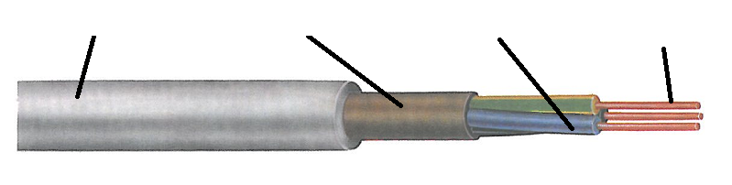

- Navedi boje žila kod četvorožilnog provodnika sa zaštitnim provodnikom.

3 žilni
4 žilni
- žilni

- Navedi boje žila kod četvorožilnog provodnika bez zaštitnog provodnika.
4 | dvije crne, braon i svijetlo plava

- Objasni zadatak omotača kod energetski izolovanog provodnika
...........................................................................................................................................................................................................................................................................................................................................................................................................................................................................................................................
- Objasni zadatak plašta kod energetski izolovanog provodnika
............................................................................................................................................................................................................................................................................................................
- Nabroj izolacione materijale koji se najčešće upotrebljavaju.
polivinilhlorid, polietilen, neopren, politen, silikonska guma i dr.
- Označavanje energetski izolovanih provodnika
Prva grupa daje podatak o:.........................................................................................................................
.......................................................................................................................................................................
Druga grupa daje podatak o: ..........................................................................................
.......................................................................................................................................

Treća grupa daje podatak o:...........................................................................................
.................................................................................................................................

Četvrta grupa daje podatak o:..........................................................................................
...........................................................................................................................................
Peta grupa daje podatak o:..................................................................................................
............................................................................................................................................

Šesta grupa daje podatak o:................................................................................................
............................................................................................................................................

