COMPUTERS & ME: MATCHING
Write the names under the correct pictures:

 |  |  |  |  | 
 |  | E-MAIL  HARD DISK  MICROPHONE  LAPTOP  MUSIC MIXER  CD  PRINTER  MOUSE  MONITOR  CD BURN  SMARTCARD  WIFI  MOTHERBOARD  HEADPHONES  SCANNER  SPEAKERS  PDA  MODEM  SAVE AS  NETWORK  BUG  PEN DRIVE  CHIP  SHIELD  FLOPPY DISK  TABLET  FLAT SCREEN  GAME CONSOLE  TEXT DOCUMENT  MOUSEMAT  CHAT  WEBCAM  USER TRASH  JOYSTICK  COMPUTER CASE  KEYBOARD |  |  | 
 | 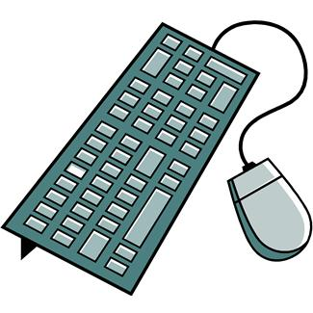 |  |  | 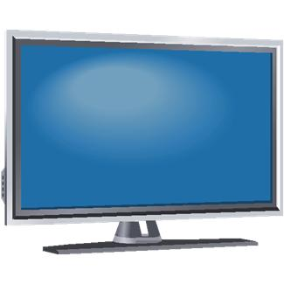 | 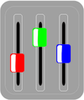
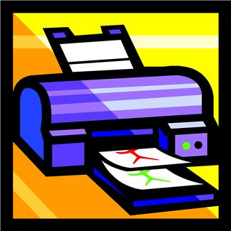 | 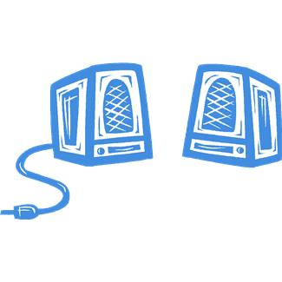 |  |  | 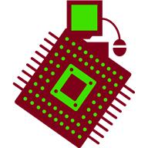 | 
 | 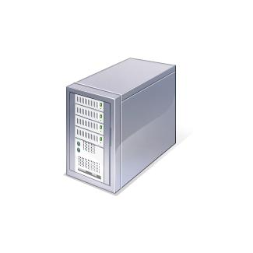 |  |  | 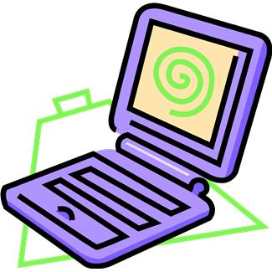 | 
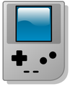 | 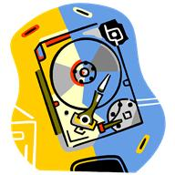 |  |  | 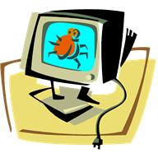 | 
 |  |  |  | 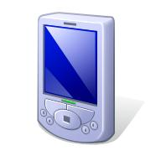 | 
 |  |  |  |  | 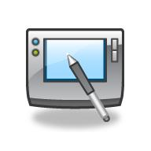

KEY

monitor user trash headphones joystick shield smartcard
CD email floppy disk microphone
pen drive keyboard flat screen music mixer
printer speakers motherboard mouse
save as computer case laptop webcam
game console hard disk bug mouse mat
scanner wifi PDA CD burn
network chip text document chat group modem tablet

