* 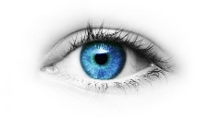 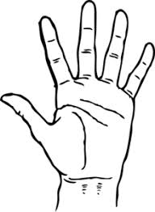   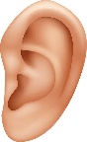

BODY IDIOMS

* + laugh someone’s head off -laugh very loudly (smijati se iz sveg glasa)
  + on the tip of someone’s tongue-when a person can’t remember something, although he/she knows it (na vrh jezika
  + give someone a hand – help someone(dati ruku pomoci)
  + pull someone’s leg- joke with somebody(saliti se sa nekim)
  + break someone’s heart – heart deeply someone’s feelings (slomiti srce)
  + can’t believe someone’s eyes-to be extremely surprised(ne vjerovati sopstvenim ocima)

BODY INJURIES

* break an arm/a leg/a rib= slomiti ruku/nogu/rebro
* a bruise on an elbow=modrica na laktu
* burn finger=opeci(izgoreti) prst
* cut hand/lip=posjeci saku/usnu
* dislocate shoulder/thumb=iscasiti rame/palac
* a scratch on the leg=ogrebotine na nozi
* sprain an ankle=uganuti zglob

Exercises (homework):

I Complete each expression with one word.

1 That will _____________her heart.

2 He was pulling your______ .

3 She couldn’t ____________her eyes.

4 It’s on the tip of my __________

5 I laughed my______________ off.

6 Can you give me a_____________ ?

II Write the correct word (body idioms,body parts, injuries)

1. Jack has ___________thumb. He didn’t put the glove on when he took the pizza out of the oven.
2. Look at the size of the muscles in her ___________.She must be a marathon runner.
3. What is the actress in The Hunger Games called? It’s on the tip of my _______.Jennifer something.
4. When I saw a comedian on television last night. I laughed my _____off.
5. Lucy has a _____on her foot.She stepped on some broken glass.
6. When he showed us the bruise, we couldn’t believe our ______. It covers the whole of her thigh.