|  |  |  |
| --- | --- | --- |
| Electrical Parameter | Measuring Unit | Symbol |
| voltage | Volt | V |
| current | Ampere | I |
| resistance | Ohm | Ω |
| conductance | Siemen | Ʊ |
| capacitance | Farad | C |
| charge | Coulomb | Q |
| inductance | Henry | H |
| frequency | Watts | W |
| power | Hertz | Hz |

STANDARD ELECTRICAL UNITS OF MEASURE

Explain the following electrical circuits

A)

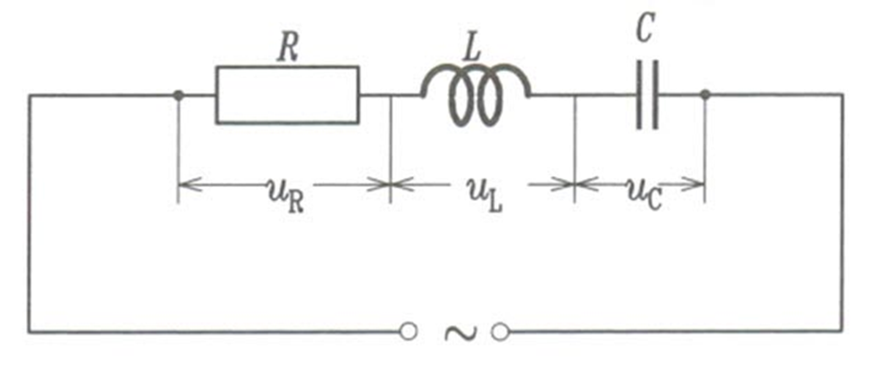

B)

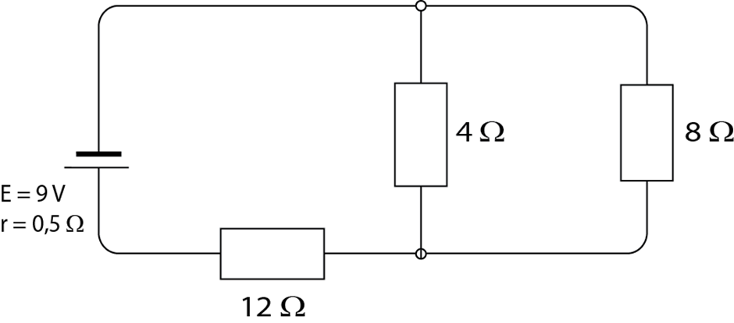

Useful vocabulary:

* series/parallel resistor connection(redna/ paralelna veza otpornika)
* a simple electrical circuit(jednostavna elektricna sema)
* AC power source (naizmjenicni izvor napajanja)
* rechargeable resource-battery (izvor koji se moze napuniti- baterija)
* DC power source (jednosmjerni izvor napajanja)

|  |
| --- |
| Directions (Uputstva):  Answer these questions and you will get the correct answer.   1. What can you see in the first/second circuit? 2. How are all the components joined? 3. What source of power are they connected to? |