**Have you ever travelled by airplane? Where did you go?**



**Have you ever eaten Chinese food? What other international food have you tried?**



**Have you ever met anyone famous? Who did you meet?**



**Have you ever been abroad?Which countries have you visited?**



**Have you ever had a pet? What kind of pet did you have?**



**Have you ever been on a beach holiday? Where were you?**



**Have you ever been on a concert? Whose concert was it?**



**Have you ever won anything? What was it?**



**Have you ever bought anything from the Internet? What was it?**



**Have you ever been camping? Did you enjoy it?**

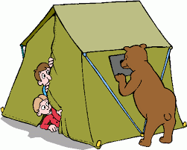

**Have you ever cried because of a film? Which film made you cry?**



**Have you ever been to another continent? Which continent was it? Which continent would you like to see?**

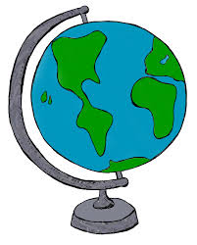

**Have you ever had a broken bone? What happened?**



**Have you ever ridden a horse? Did you enjoy it?**



**Have you ever been late for school? Why were you late?**



**Have you ever tried an extreme sport? What was it? Was it scary?**

