***UNIT 4 THE COST OF LIVING***

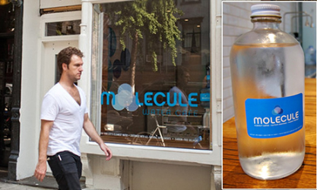 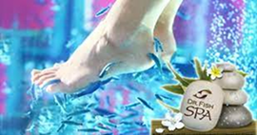

**Molecule Water Café – New York**  **Dr Fish Spa -Istanbul**

VOCABULARY 4.1 **COOL PLACE TO HANG OUT IN TOWN**

1. **Phrasal verbs – shopping and money**

***to shop around*** - to look for the most suitable item or service for the lowest price-razgledati

***to bring sth out*** – to produce sth to sell to the public (launch) -lansirati

***to rip sb off*** – cheat sb (charge too much money for the product)-opelješiti pri kupovini

***to snap sth up*** – to buy or take quickly or eagerly-razgrabiti

***to splash out on*** – to spend a lot of money-razbacivati se sa novcem

***to fork out*** – spend money on sth, when you don’t want to-baciti pare na nešto

1. **Money idioms**

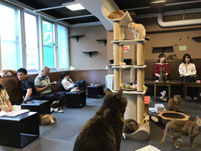

**Cat café – Tokyo**

***cost an arm and a leg*** – to be too expensive-preskupo ***have money to burn*** – a large amount of money to spend

***make ends meet*** – to earn enough money to buy what you need to live-sastaviti kraj sa krajem

***pay through the nose*** -pay too much money for sth-izaći na nos

1. **Collocations**

***a range of products***…- a number of different things of the same general kind-spektar proizvoda

***a chain of cafes***… - a number of cafes …owned by the same person or company-lanac kafića

***value for money*** – things sold at a good price (the most advantageous combination of cost and quality) stvari plaćene koliko i vrijede

***fill in a gap in the market*** – an opportunity to produce sth that is not yet available but people would like to have-popuniti rupu na tržištu

***niche market*** – a small specialized market for particular product or service-specijalizovana radnja za odredjeni proizvod

***sustainable fashion*** – clothing that is designed,manufactured, distributed and used in ways that are environmentally friendly