UNIT 3

A PLACE TO LIVE-key words

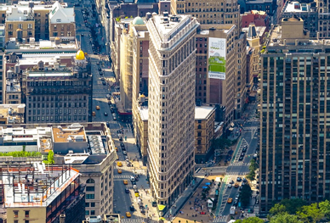

***Compile****-*produce (a list or book) by assembling information collected from other sources -

***Landmark****-* a structure (such as a building) of unusual historical and usually aesthetic interest especially : one that is officially designated and set aside for preservation-obilježje, zaštitni znak

***Benefit from****-* receive an advantage; profit-imati koristi

***Vibrant****-* full of energy and life-zivahan, dinamičan

***Mouth-watering food****-* delicious, tasty-ukusan

***Boast***-(of a person, place, or thing) possess (a feature that is a source of pride)-pucati ( od ponosa, sreće, zadovoljstva)

***River mouth****-*a place where river enters a lake, larger river, or the ocean *-ušće*

***Cosmopolitan****-* including people from many different countries-internacionalni

***Bustling****-* (of a place) full of activity-užurban

***Renowned for****-* famous for-poznat

***Offset by****-* compensate