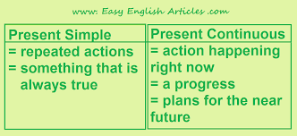PRESENT SIMPLE vs. PRESENT CONTINUOUS

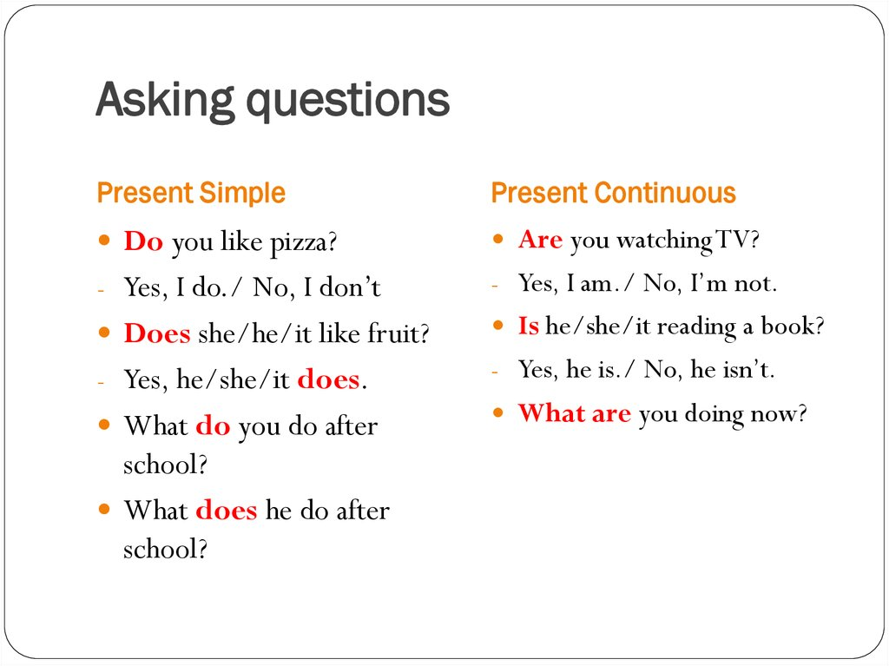

**1. How often __________________________________?**

**Peter goes swimming three times a week.**

**2. How many languages __________________________?**

**He speaks German, Spanish and Russian.**

**3. Why ________________________________________?**

**I’m crying because I’m so upset today.**

**4. Where ______________________________________?**

**They usually spend their weekends in the country.**

**5. When ______________________________on holiday?**

**Kate is going on holiday at the end of the month.**

**6. What time ___________________________________?**

**Paul finishes his work at 6.30.**

**7. What ________________________________this term?**

**He is studying English and Literature this term. 7**

**1) Complete the questions. Use the present simple or the present continuous.**

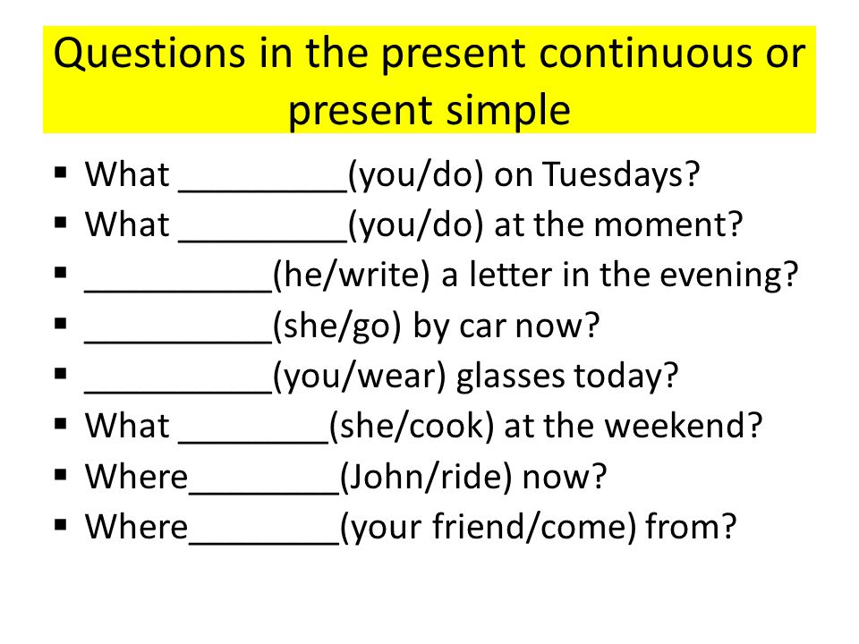

**2) Complete the questions. Use the present simple or the present continuous.**