The Perfect Crime?
- READ THE TEXT. THEN ANSWER THE QUESTIONS.

DB Cooper hijacked an aeroplane in the United States on 24th November, 1971. He received $200,000 in ransom money and parachuted from the plane. He was never arrested. In fact, he was never found, and neither was most of the money. The FBI continued to investigate the incident for many years. They investigated more than a thousand suspects. In the end, they decided that Cooper didn’t survive the jump, but many people believe that Cooper managed to escape. They would like to know what happened to him.
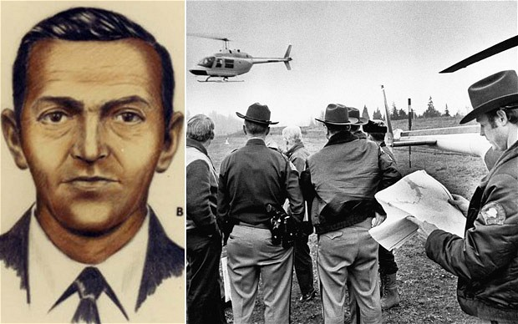
Cooper boarded the aeroplane in Seattle. He was wearing a black raincoat, a dark suit, a white shirt, a black tie and black sunglasses. Witnesses said that he didn’t look suspicious in any way. He sat at the back of the plane. After the plane had taken off, he handed a note to a flight attendant. The note said: “I have a bomb.” It also demanded $200,000 in cash and some parachutes.

The pilot didn’t take any chances. He quickly landed at Seattle International Airport, where Cooper was given $200,000 and the parachutes that he had asked for. Cooper then ordered the flight crew to take the plane back into the air. Once the plane was back in the air, Cooper tied something to his waist. He ran to the door of the plane, opened it and jumped out. He was never seen again.

At the time Cooper jumped, the plane was flying through a heavy rainstorm and it was very difficult to see anything. That is why the jets that were instructed to follow the plane didn’t notice him when he jumped. Although the FBI carefully searched the area, no trace of Cooper or his parachute was ever found. Did he die or did he escape and commit the perfect crime? It seems we will never know.

- What does the FBI think happened to Cooper?

- Why did the pilot quickly land the aeroplane?

- How did the weather help Cooper?

- COMPLETE THE SENTENCES ACCORDING TO THE INFORMATION IN THE TEXT. USE THE PAST PERFECT SIMPLE TO COMPLETE THE SENTENCES.
1. Cooper didn’t give the ransom note to the flight attendant until...
2. Cooper jumped out of the plane after he...
3. Some people believe that before the FBI arrived to search the area, Cooper...

- THESE WORDS ABOVE APPEAR IN THE TEXT The Perfect Crime? FIND THEM AND GUESS THEIR MEANINGS IN YOUR OWN LANGUAGE.

1. ransom money ______________ 4. suspicious ______________
2. parachuted ______________ 5. jets ______________
3. boarded ______________ 6. trace ______________

The Perfect Crime?
- READ THE TEXT. THEN ANSWER THE QUESTIONS.

DB Cooper hijacked an aeroplane in the United States on 24th November, 1971. He received $200,000 in ransom money and parachuted from the plane. He was never arrested. In fact, he was never found, and neither was most of the money. The FBI continued to investigate the incident for many years. They investigated more than a thousand suspects. In the end, they decided that Cooper didn’t survive the jump, but many people believe that Cooper managed to escape. They would like to know what happened to him.
Cooper boarded the aeroplane in Seattle. He was wearing a black raincoat, a dark suit, a white shirt, a black tie and black sunglasses. Witnesses said that he didn’t look suspicious in any way. He sat at the back of the plane. After the plane had taken off, he handed a note to a flight attendant. The note said: “I have a bomb.” It also demanded $200,000 in cash and some parachutes.

The pilot didn’t take any chances. He quickly landed at Seattle International Airport, where Cooper was given $200,000 and the parachutes that he had asked for. Cooper then ordered the flight crew to take the plane back into the air. Once the plane was back in the air, Cooper tied something to his waist. He ran to the door of the plane, opened it and jumped out. He was never seen again.

At the time Cooper jumped, the plane was flying through a heavy rainstorm and it was very difficult to see anything. That is why the jets that were instructed to follow the plane didn’t notice him when he jumped. Although the FBI carefully searched the area, no trace of Cooper or his parachute was ever found. Did he die or did he escape and commit the perfect crime? It seems we will never know.

- What does the FBI think happened to Cooper?
They think he didn’t survive the jump.
- Why did the pilot quickly land the aeroplane?
He didn’t want to take any chances. (The plane was in danger with Cooper’s bomb on board).

- How did the weather help Cooper?
It was difficult to see anything, so nobody noticed him when he jumped.

- COMPLETE THE SENTENCES ACCORDING TO THE INFORMATION IN THE TEXT. USE THE PAST PERFECT SIMPLE TO COMPLETE THE SENTENCES.
1. Cooper didn’t give the ransom note to the flight attendant until... the plane had taken off.

2. Cooper jumped out of the plane after he... had tied something to his waist.
3. Some people believe that before the FBI arrived to search the area, Cooper... had managed to escape.
- THESE WORDS ABOVE APPEAR IN THE TEXT The Perfect Crime? FIND THEM AND GUESS THEIR MEANINGS IN YOUR OWN LANGUAGE.

1. ransom money ______________ 4. suspicious ______________
2. parachuted ______________ 5. jets ______________
3. boarded ______________ 6. trace ______________

SOME FACTS ABOUT THIS MYSTERY. EXPLAIN IT WITH YOUR OWN WORDS.
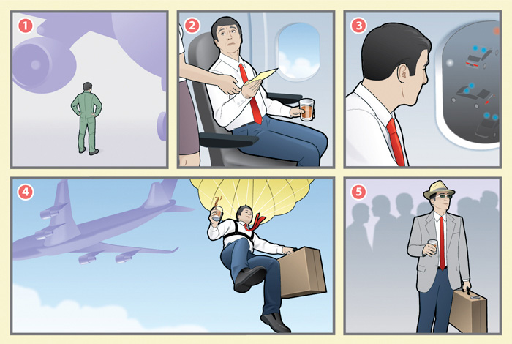

Northwest Orient Airlines Flight 305
Hijacking summary
Date | November 24, 1971
Type | Hijacking
Site | Between Portland, Oregon and Seattle, Washington, USA
Passengers | 36 plus hijacker
Crew | 6
Injuries | none known
Fatalities | none known (hijacker's fate unknown)
Survivors | All 42 passengers and crew
Aircraft type | Boeing 727
Operator | Northwest Orient Airlines
Flight origin | Portland International Airport
Destination | Seattle-Tacoma International Airport

