UNIT 3
A PLACE TO LIVE-key words
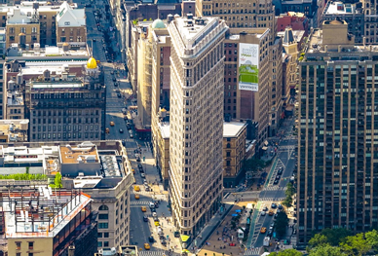

Compile-produce (a list or book) by assembling information collected from other sources -
Landmark- a structure (such as a building) of unusual historical and usually aesthetic interest especially : one that is officially designated and set aside for preservation-obilježje, zaštitni znak
Benefit from- receive an advantage; profit-imati koristi
Vibrant- full of energy and life-zivahan, dinamičan
Mouth-watering food- delicious, tasty-ukusan
Boast-(of a person, place, or thing) possess (a feature that is a source of pride)-pucati ( od ponosa, sreće, zadovoljstva)
River mouth-a place where river enters a lake, larger river, or the ocean -ušće
Cosmopolitan- including people from many different countries-internacionalni
Bustling- (of a place) full of activity-užurban
Renowned for- famous for-poznat
Offset by- compensate

