2.4. HOUSTON, WE HAVE A PROBLEM- vocabulary
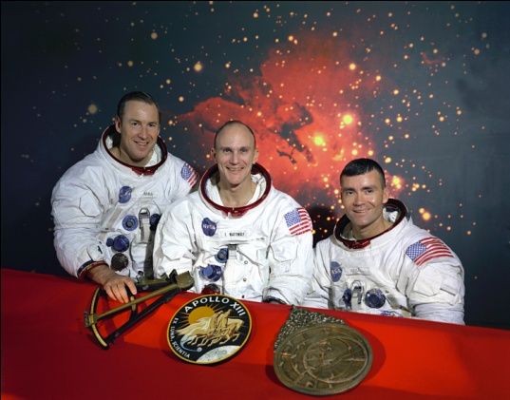
breathe the sigh of relief- not be worried any more
carry out- do/take part in
come up with- produce, think of
figure out- understand
find a solution -resolve
fix a problem- resolve, repair
follow events-come after, go after, come next
get home- arrive home
go crazy- become crazy
on duty- working
raise your hand- lift your hand
run out- no more left
splash down - to land in a body of water
hatch- small door
launch- to send it into the air or into space.


parachute-

bored to tears- extremely bored
orbit - move around a planet, moon, sun it in a continuous, curving path.
outer space- is the area outside the earth's atmosphere where the other planets and stars are situated.

