Parts of the body Injuries Body idioms
1 Write the body parts.
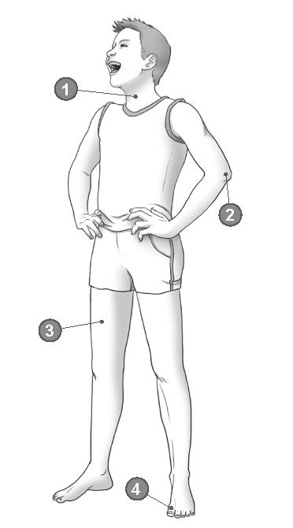

1 n
2 e
3 t
4 t
/4

2 Complete the sentences with the verbs in the correct form.
1 One of the players d _ _ l _ c _ t _ d his shoulder.
2 I fell off my bike and b _ _ _ s _ d my knee.
3 The soup’s very hot – be careful you don’t b _ _ n your tongue.
4 I b _ _ _ e my finger playing volleyball, so it’s going to be in plaster for three weeks.
/4

3 Complete the sentences with the words in the box. There are two words you don’t need.
eyes foot hand head heart leg
1 It was really funny – I laughed my off!
2 I couldn’t believe my when my brother walked in.
3 Can you give me a with this suitcase?
4 Don’t worry, I was only pulling your .
/4

4 Choose the correct words.
1 I’ve got a nasty scratch at / on / in my leg.
2 I was lucky because I only got / made / did a few cuts and scratches.
3 The most common injury is a sprain / sprained / sprains ankle.
/3

5 Complete the sentences with the correct form of the words in the box. There are three words you don’t need.

audition compete competition contestant editor entertainment viewer

1 The programme has over 3 million who watch every week.
2 The producers aim to create good for all the family.
3 If you do a good , you will be invited to take part in the show.
4 Have you ever thought about entering a talent ?
/4

6 Choose the correct words.
1 Audience participation in the show is absolutely important / essential.
2 Last night we watched a programme about life in the past. There were some very interesting / fascinating facts.
3 Their new comedy is very / absolutely hilarious.
4 The first show was really / extremely awful.
/4

7 Complete the words in the sentences.
1 The presenter decides what to say on the show. She doesn’t read from a s .
2 The first e of the drama series was last week.
3 Do you sing in a band, or are you a s singer?

8 Complete the sentences with the words in the box. There are three words you don’t need.
appreciation donation employment engagement friendship neighbourhood stupidity
1 We gave him a small gift to show our for what he had done.
2 Molly was showing all her friends her ring, and talking about her plans for the wedding.
3 This is a really nice to live in.
4 I was shocked at the of what she was saying – it didn’t make sense at all.
/4

9 Complete the sentences with adjectives formed from the words in the box. There is one word you don’t need.
job honour hope risk sympathy
1 If the factory closes down, 300 people will become .
2 My parents were very when I told them about my problems.
3 The thing would be to tell the truth. It wouldn’t be right to lie about it.
4 He’s that he will be able to find somewhere to live now.
/4

10 Choose the correct words.
1 This is a story which will really heat / warm your heart.
2 That old comedy always puts / gets a smile on my face.
3 Try to do / make a good deed every day.
/3

11 Read the text below and decide which answer (A, B, C or D) best fits each gap.
A role model’s responsibilities
When Mo Farah (1) gold medals in both the 5,000 metres and the 10,000 metres at the 2012 Olympic Games, he became an instant hero and role model to many young people in Britain.
Mo was born in Somalia but he (2) to England at the age of 8. He was soon winning titles and (3) new records, including running the fastest ever 3,000 metres by a British runner in January 2009. His performances improved, and he (4) his own record just a few months later.
However, in early 2014, he (5) photos of himself on one of the social media sites, (6) into the sea from 30-metre high cliffs. Critics said that young people who
(7) up to him might copy his behaviour. Many young people have been killed or have suffered spinal
(8) and become permanently disabled doing similar things because the water wasn’t as deep as they had thought.
However, (9) of the runner were quick to defend him. They argued that his profile page was not widely viewed, and the pictures hadn’t (10) viral. They said that it was the newspapers who had drawn attention to the photos by printing them, and they were therefore far more irresponsible than Mo Farah.
1 A beat B won C scored D came
2 A arrived B reached C left D came
3 A getting B winning C setting D making
4 A broke B got C did D gained
5 A downloaded B interacted C posted D followed
6 A throwing B catching C jumping D kicking
7 A looked B saw C viewed D considered
8 A conditions B illnesses C diseases D injuries
9 A viewers B fans C spectators D audience
10 A made B got C come D gone
/10

