What ArWhat Are Common Components of a Security System?

A home security system consists of different components, including motion sensors, indoor and outdoor cameras, glass break detectors, door and window sensors, yard signs and window stickers, smoke detectors, and carbon monoxide detectors

Sensors

It is a component that is usually used to detect noise or a movement. Sensors are usually connected to the circuit. As soon as it detects the slightest noise or movement it initiates the circuit which results in triggering the buzzer and the flashing light.
- Motion sensors
They are an essential part of any home security system. They have a wide variety of uses: turning on indoor and outdoor lights, activating cameras, setting off alarms, and more. For this reason, they are often incorporated into other home alarm system equipment.
- Door and Window Sensors

Door and window sensors detect when the door or window they are attached to opens. These devices use two sensors: one on the door or window, and one on the frame. When the door is closed, the two sensors form a closed circuit. When the door is opened, the circuit breaks, triggering a burglar alarm or text alert.
- Heat Sensors

Fires typically cause a rapid rise in temperature in the surrounding area. Heat detectors sense the rise in temperature and signal an alarm if the increase is 15 degrees or more per minute or if the environmental temperature rises above 135 degrees. Best locations for heat sensors are areas such as attics and garages.
- Temperature Sensors

Temperature sensors accurately measure ambient temperatures in your environment. If the temperature goes above or below the pre-set standards, the unit will contact the monitoring station. These sensors can help prevent freezing pipes in vacation homes or other buildings.
- Indoor and Outdoor Cameras
Security cameras are another core security system part. Cameras can be used to record areas of your home or yard, and some can also send the feed straight to your smartphone or tablet.Cameras are also used in new and clever ways, from doorbell cameras that are all but invisible to smart cameras.
- Motion detector
This detector sends out bursts of ultrasonic sound waves and then waits for the reflected energy to bounce back. If there is no one interrupting the signal, the radio energy will bounce back in the same pattern. But if somebody enters the area, the reflection pattern is disturbed and the alarm sounded.
- Glass Break Detectors
Glass break detectors are handy sensors that detect the frequency the sound of shattering glass makes and set off an alarm. These are useful to let you know if someone attempts to enter your home by breaking the windows or glass doors, making them an essential alarm system component
- Carbon Monoxide Detectors
Carbon monoxide (CO) is an invisible, odorless, colorless gas created when fuels, such as gasoline, wood, coal, natural gas, propane, oil and methane, burn incompletely. Called the “silent killer” because you can’t see or smell it, CO enters the body through breathing.

Control Panel (System Controller)
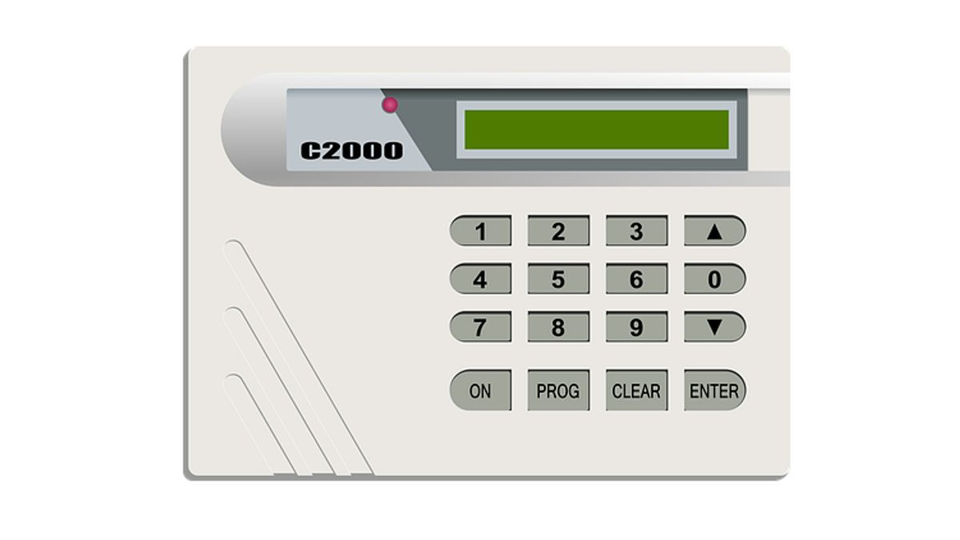
The control panel is the “brains” of the security system. It may look like an electrical box or be inside the keypad. It receives transmissions from sensors and communicates data to the central monitoring station. The battery is located inside the control panel, which backs up the system if your power is shut down.

Keypads
Keypads are units that can be installed throughout your home to provide easy-to-use access to your panel. By typing in your personal code and the correct buttons, you can arm and disarm your security system quickly.

Indoor and Outdoor Cameras

Cameras are a crucial part of any home security system. They allow the recording of a particular area of your home and, allows you to view those areas straight to your phone, tablet or other device.Cameras can be visible or concealed, wireless or wired
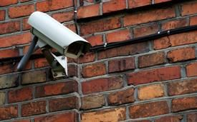

Yard Signs and Window Stickers

Signs and stickers around your home may seem like a strange addition to this list, but they are the ‘invisible’ layer of protection that you don’t think about. By placing signs and stickers around your property showing that you have a security system in place, it acts as a deterrent for thieves who are thinking about robbing your home.



