- 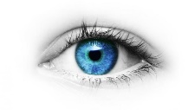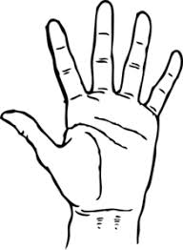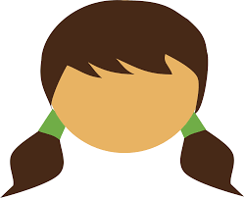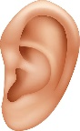
BODY IDIOMS
  - laugh someone’s head off -laugh very loudly (smijati se iz sveg glasa)
  - on the tip of someone’s tongue-when a person can’t remember something, although he/she knows it (na vrh jezika
  - give someone a hand – help someone(dati ruku pomoci)
  - pull someone’s leg- joke with somebody(saliti se sa nekim)
  - break someone’s heart – heart deeply someone’s feelings (slomiti srce)
  - can’t believe someone’s eyes-to be extremely surprised(ne vjerovati sopstvenim ocima)
BODY INJURIES
- break an arm/a leg/a rib= slomiti ruku/nogu/rebro
- a bruise on an elbow=modrica na laktu
- burn finger=opeci(izgoreti) prst
- cut hand/lip=posjeci saku/usnu
- dislocate shoulder/thumb=iscasiti rame/palac
- a scratch on the leg=ogrebotine na nozi
- sprain an ankle=uganuti zglob

Exercises (homework):
I Complete each expression with one word.
1 That will _____________her heart.
2 He was pulling your______ .
3 She couldn’t ____________her eyes.
4 It’s on the tip of my __________
5 I laughed my______________ off.
6 Can you give me a_____________ ?

II Write the correct word (body idioms,body parts, injuries)
- Jack has ___________thumb. He didn’t put the glove on when he took the pizza out of the oven.
- Look at the size of the muscles in her ___________.She must be a marathon runner.
- What is the actress in The Hunger Games called? It’s on the tip of my _______.Jennifer something.
- When I saw a comedian on television last night. I laughed my _____off.
- Lucy has a _____on her foot.She stepped on some broken glass.
- When he showed us the bruise, we couldn’t believe our ______. It covers the whole of her thigh.

