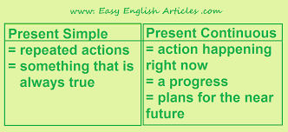

PRESENT SIMPLE vs. PRESENT CONTINUOUS
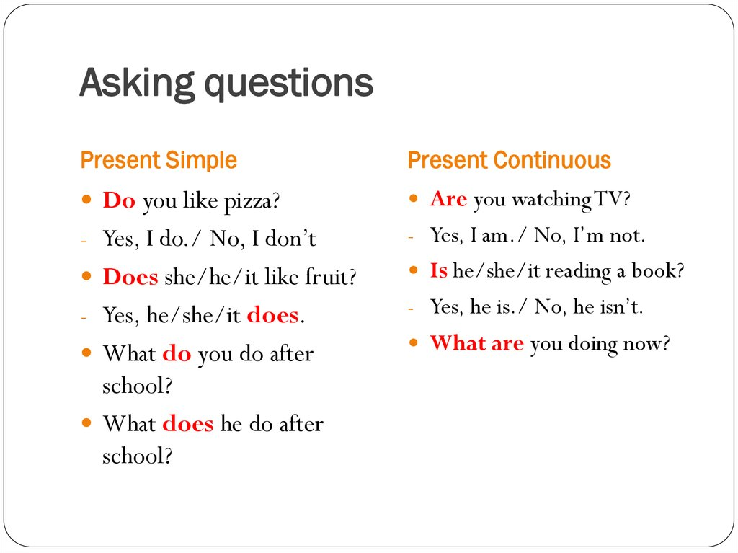
1. How often __________________________________?
Peter goes swimming three times a week.
2. How many languages __________________________?
He speaks German, Spanish and Russian.
3. Why ________________________________________?
I’m crying because I’m so upset today.
4. Where ______________________________________?
They usually spend their weekends in the country.
5. When ______________________________on holiday?
Kate is going on holiday at the end of the month.
6. What time ___________________________________?
Paul finishes his work at 6.30.
7. What ________________________________this term?
He is studying English and Literature this term. 7

1) Complete the questions. Use the present simple or the present continuous.
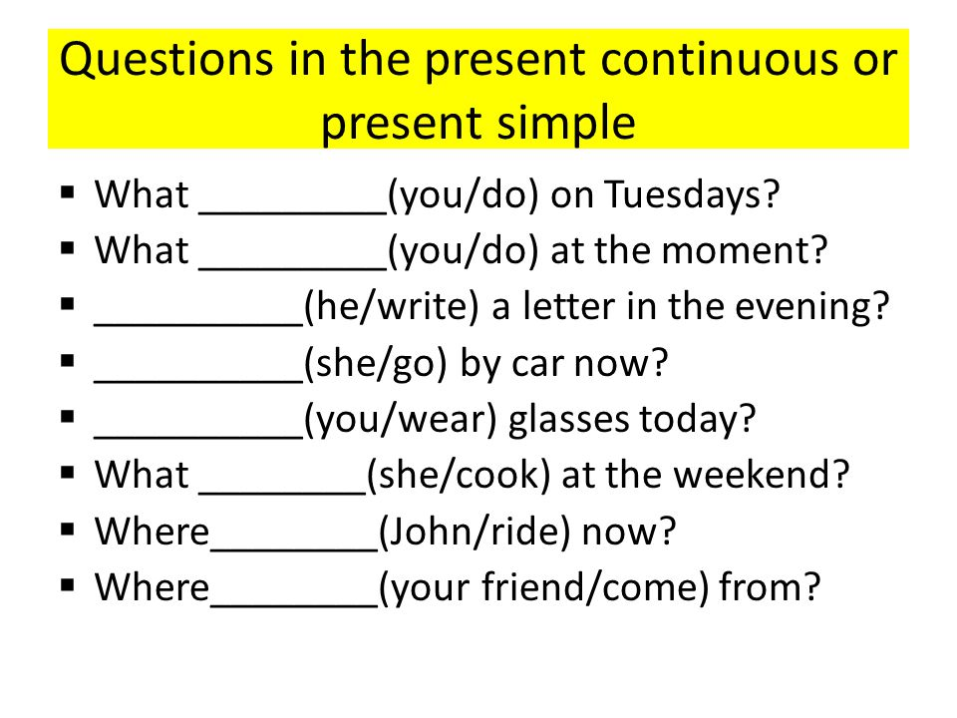
2) Complete the questions. Use the present simple or the present continuous.

