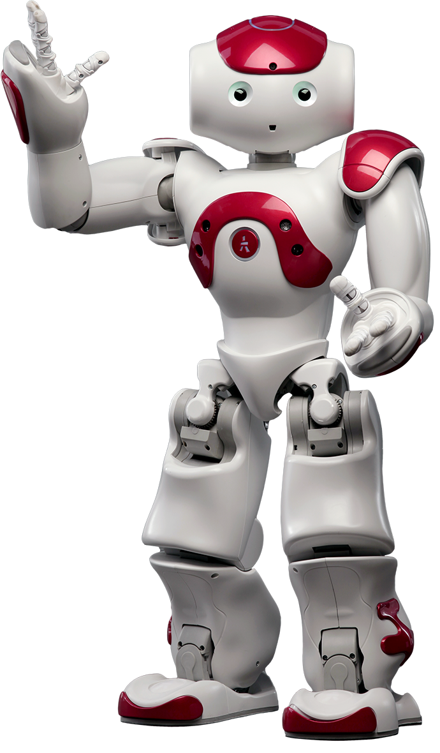
far future - you can’t do anything about it. (0)
personal opinions about the future. (1)
predictions without firm evidence. (2)
spontaneous decisions or offers (while speaking) (3)
future facts and first conditionals (4)
requests, wishes, promises, hopes, threats (5)

Signal Words: probably, maybe, perhaps, likely, one day, in the future, in 2050, I think / believe / expect, in my opinion, I’m sure, I’m afraid, I hope / wish / promise…

Complete the sentences with the correct
future form of the verbs given.
Add the future use expressed in brackets
from (1) to (18). Follow the example.

- My father hasn’t got much hair. He ___will have lost____ (lose) it all soon. (18)
- In 150 years, men ______________ (likely /be) bald.
- When I’ve saved some money, I ___________________ (buy) a new ipad.
- Everybody expects the owners ___________________ (sign) the agreement with Bill Gate’s company.
- Be careful. Geminis _____________________ (have) money problems this week.
- Don’t phone me this evening. I ___________________ (study) for my English exam.
- Let’s have a snack. Dinner _______________ (not be) ready for another hour.
- What? OK, I __________________ (fix) it in a minute.
- I’ll clean the house before mum __________________ (come).
- The water is already very hot. It _________________ (boil) in a minute.
- Lucky you! At this time tomorrow, you ___________
________________ (swim) in the Caribbean!
- If you _________________ (believe) that you will pass the test, you ____________________ (get) it.
- I _________________________ (go trekking) in Mexico next month.
- In a hundred years, the ice caps _________________ (melt) unless we stop the global warming.
- Move, bloke! That cyclist ______________________ (crash into) you!
- The train from Bolton ___________________ (arrive) at 8:15 at Victoria Station. I always take it on Saturdays to go to the city center.
- Uncle David __________________ (fly) to Moscow to visit my cousin in a few weeks.
- Let’s not make plans for Liz’s first night home. She _____________________ (drive) for 12 hours and I’m sure she _________________ (be) exhausted.
- What shoes ________________________ (you / wear) for our hike –trainers or hiking boots?
- Do you think they ______________________ (build) a high-speed rail system by the end of 2025?
- I ______________________ (go fishing) with some friends early next Sunday. I hope it ______________ (not be) too boring!
- I _____________ (tidy) this mess, mum. I promise.
- ______________________ (he / test) his eyes at 5?

general plans, arrangements for a certain future (6)
intentions, resolutions, firm decisions (near future) (7)

predictions based on evidence (8)

Signal Words: look at …, watch out!; my intention / plan is …, actions such as getting out the umbrella…

appointments / arrangements (i.e. at the dentist) (10)
fixed plans / dates (parties) – specific time or place (11)
programmed events (fights, interviews, weddings) (12)

with verbs of movement (to avoid repetition) (13)

Signal Words: on Monday at 5 o’clock, this afternoon, tomorrow evening

scheduled actions, fixed timetables (stations, cinemas) (14)
in future time clauses (after conjunctions of time) (15)
in first conditional clauses (16)

Signal Words:
before, after, until, till, as soon as, when, while, once
if, unless, provided that, as long as

Actions in progress at a specific or certain time in the future – already planned or routines. (17)

Signal Words: (at)this time next (week), in (6 months’) time, next (weekend), at (8) this (evening), in (20) years

actions completed by specific or certain time in the future. (18)

Signal Words: by 2030, by the end of (the year), by now, by then, by (five years), by the time (you)…, this time tomorrow, in (ten years’) time, in (four months), soon.

far future - you can’t do anything about it. (0)
personal opinions about the future. (1)
predictions without firm evidence. (2)
spontaneous decisions or offers (while speaking) (3)
future facts and first conditionals (4)
requests, wishes, promises, hopes, threats (5)

Signal Words: probably, maybe, perhaps, likely, one day, in the future, in 2050, I think / believe / expect, in my opinion, I’m sure, I’m afraid, I hope / wish / promise…

Complete the sentences with the correct
future form of the verbs given.
Add the future use expressed in brackets
from (1) to (18). Follow the example.

- My father hasn’t got much hair. He ___will have lost____ (lose) it all soon. (18)
- In 150 years, men _will likely be_ (likely /be) bald. (0)
- When I’ve saved some money, I _am going to buy__ (buy) a new ipad. (7)
- Everybody expects the owners _____will sign______ (sign) the agreement with Bill Gate’s company. (5)
- Be careful. Geminis _____will have________ (have) money problems this week. (2)
- Don’t phone me this evening. I ___will be studying_ (study) for my English exam. (17)
- Let’s have a snack. Dinner ____won’t be ready____ (not be) ready for another hour. (4)
- What? OK, I ___will fix______ (fix) it in a minute. (3)
- I’ll clean the house before mum _____comes_______ (come). (15)
- The water is already very hot. It _is going to boil__ (boil) in a minute. (8)
- Lucky you! At this time tomorrow, you __will be__
___swimming___ (swim) in the Caribbean! (17)
- If you ____believe_____ (believe) that you will pass the test, you ______will get_____ (get) it. (16) - (4)
- I __am going trekking_____ (go trekking) in Mexico next month. (11)
- In a hundred years, the ice caps _will have melted_ (melt) unless we stop the global warming. (18)
- Move, bloke! That cyclist __is going to crash into_ (crash into) you! (8)
- The train from Bolton ______arrives______ (arrive) at 8:15 at Victoria Station. I always take it on Saturdays to go to the city center. (14)
- Uncle David _____is flying______ (fly) to Moscow to visit my cousin in a few weeks. (12)
- Let’s not make plans for Liz’s first night home. She ___will have driven___ (drive) for 12 hours and I’m sure she __won’t be___ (be) exhausted. (18) - (1)
- What shoes __are you going to wear__ (you / wear) for our hike –trainers or hiking boots? (6)
- Do you think they ___will have built______ (build) a high-speed rail system by the end of 2025? (18)
- I ____am going fishing_____ (go fishing) with some friends early next Sunday. I hope it ___won’t be___ (not be) too boring! (13) / (6) - (5)
- I ___will tidy__ (tidy) this mess, mum. I promise. (5)
- _Is he testing_______ (he / test) his eyes at 5? (10)

general plans, arrangements for a certain future (6)
intentions, resolutions, firm decisions (near future) (7)

predictions based on evidence (8)

Signal Words: look at …, watch out!; my intention / plan is …, actions such as getting out the umbrella…

appointments / arrangements (i.e. at the dentist) (10)
fixed plans / dates (parties) – specific time or place (11)
programmed events (fights, interviews, weddings) (12)

with verbs of movement (to avoid repetition) (13)

Signal Words: on Monday at 5 o’clock, this afternoon, tomorrow evening

scheduled actions, fixed timetables (stations, cinemas) (14)
in future time clauses (after conjunctions of time) (15)
in first conditional clauses (16)

Signal Words:
before, after, until, till, as soon as, when, while, once
if, unless, provided that, as long as

Actions in progress at a specific or certain time in the future – already planned or routines. (17)

Signal Words: (at)this time next (week), in (6 months’) time, next (weekend), at (8) this (evening), in (20) years

actions completed by specific or certain time in the future. (18)

Signal Words: by 2030, by the end of (the year), by now, by then, by (five years), by the time (you)…, this time tomorrow, in (ten years’) time, in (four months), soon.

